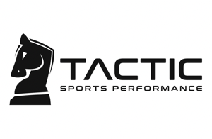
Parent Name______________________________________
Athlete Name______________________________________
Address___________________________________________
City____________________ State_______ Zip___________ Date of Birth____________
Phone#_________________ Email _____________________
Known Injuries or Illness? ___________________________________________
Waiver / Release
I, the undersigned patron of TACTIC SPORTS PERFORMANCE, hereby state and represent as follows:
I do not have, have not traveled to known locations to have, nor have been in contact with anyone known to have the COVID-19 virus. I understand the risks associated with my participation in TACTIC SPORTS PERFORMANCE programs. I have no known medical problems that would preclude me from participation in the TACTIC SPORTS PERFORMANCE training program, and the information I have provided TACTIC SPORTS PERFORMANCE, regarding my medical history and physical condition is true and correct to the best of my knowledge.
To the event of physical injury or illness resulting from my participation in the TACTIC SPORTS PERFORMANCE training program, that no medical treatment or monetary compensation will be provided to me by TACTIC SPORTS PERFORMANCE in the result of any injuries or sickness.
I hereby agree to forever waive any and all claims that I may have against TACTIC SPORTS PERFORMANCE or its agents or employees as a result of my participation in TACTIC SPORTS PERFORMANCE programs and its agents or assigns harmless from any claims resulting from my participation in the TACTIC SPORTS PERFORMANCE Program. This release shall be binding on my heirs, legal representatives, and assigns.
I have read this Release and the information provided to me by TACTIC SPORTS PERFORMANCE and understand that I am signing a complete release and bar to any claim resulting from my participation in the TACTIC SPORTS PERFORMANCE Program.
_________ ___________________________________
Date Participant Signature
___________________________________
Parent or Guardian signature (if participant is under 18)

